PATIENT NAME: YVONNE MCLAURIN (F)
INSURANCE ID#: XOG911788057 DOB: 02/28/1968
ADDRESS: 4727 N MALDEN ST UNIT114 CHICAGO, IL 60640
PHONE #: (872) 235-2014
MEDICARE DESCRIPTION AND PROCEDURE CODES:
- POWER WHEELCHAIR GROUP STANDARD CAPTAIN CHAIR - K0814 ;
- BATTERY - E2365

Power Wheelchair EZ-GO

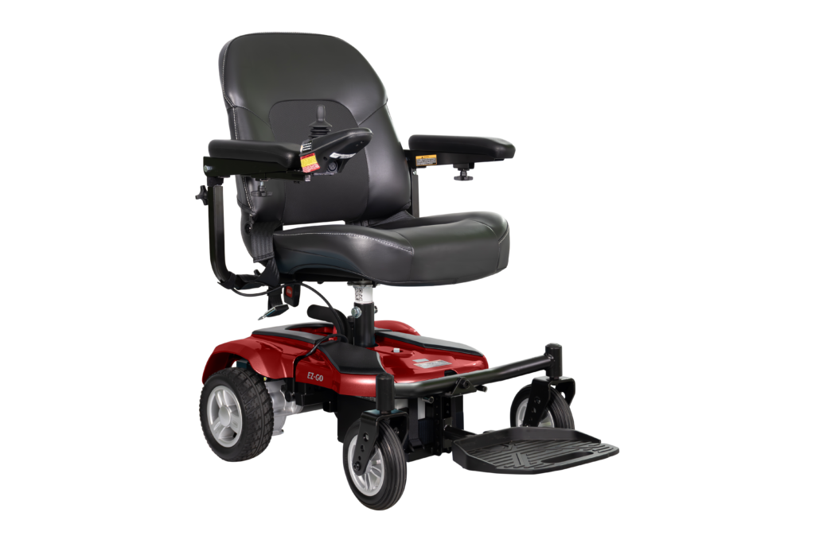

Weight Capacity | 300 LB
Drivetrain | RWD
Seat Type | Stadium
Seat Depth | 18”
Seat Width | 18”
Backrest Height | 17”
Seat-to-Floor Height | 18”-20”
Elevating Seat | N/A
Overall Length | 27”
Overall Wight | 23”
Overall Height | 43”
Total Weight | 113 LB
Max Speed | 4.5 mph
Per Charge Range | Up to 12 miles

**Patient Agreement:** I, ___________________________________ (Patient Name), acknowledge that I have reviewed the power wheelchair depicted in the accompanying picture. I understand its features and specifications and agree that this wheelchair meets my mobility needs as assessed by my healthcare provider. I consent to accept and use this specific power wheelchair as part of my mobility solution.

Patient’s Signature:___________________________________________________________ Date:_____________
Signature if other than patient:___________________________________Relationship:_____________________
Name if other than patient:_______________________________________________________________________
Reason patient is unable to sign:__________________________________________________________________
Evaluator’s Signature:_____________________________________________________ Date:________________
Evaluator’s Name (printed):______________________________________________________________________

